http://xahlee.info/js/html5_non-closing_tag.html:
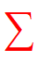 |  | 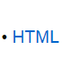 | 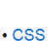 | 

List of HTML Self-Closing Tags
By Xah Lee. Date: 2012-03-23. Last updated: 2016-06-21.
Here's a complete list of self-closing tags for HTML5. These are called “void-elements” in HTML spec.
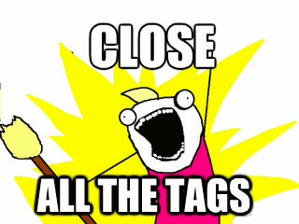
<area />
<base />
<br />
<col />
<command />
<embed />
<hr />
<img />
<input />
<keygen />
<link />
<meta />
<param />
<source />
<track />
<wbr />
The space before the slash is optional.
For a list of all HTML5 tags, see: HTML5 Tags Complete List.

Is the Ending Slash Optional?
- HTML5: the slash is optional.
- HTML4: the slash is technically invalid. However, it's accepted by W3C's HTML validator.
- XHTML: The slash is REQUIRED.
I recommend to always add the slash. Because, it provides a visual clue of non-closing tags. It's also convenient if you write simple script to check your HTML, without a lookup table or using heavy HTML parser.

XHTML Supports Self-Closing Syntax for All Tags
In XML/XHTML, any tag can be self-closed by the ending slash <… />.
When you test XML, you have to make sure the server is sending the correct Internet media type as XHTML (For example, application/xhtml+xml), otherwise browsers will treat it as HTML, regardless of the DOCTYPE in your file.

Reference
http://www.w3.org/TR/2011/WD-html-markup-20110113/syntax.html#void-element

